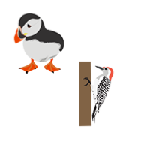
Year 3 Termly Plan 3

SUBJECT | WEEK 1 | WEEK 2 | WEEK 3 | WEEK 4 | WEEK 5 | WEEK 6
GUIDED READING   | Meet the Egyptians  Explore a new text  Vocabulary  Retrieval  Inference | Meet the Egyptians  Summary and sequence  Inference  Dig deeper into a text, specific to the characters and their qualities  Prediction | Marcy and the Riddle of the Sphinx by Joe Todd-Stanton  Explore a new text  Vocabulary  Retrieval  Inference  Dig deeper into characters - How do perceptions change? | Marcy and the Riddle of the Sphinx by Joe Todd-Stanton  Vocabulary  Retrieval  Summarise and sequence  Inference | Marcy and the Riddle of the Sphinx by Joe Todd-Stanton  Explore a new text  Vocabulary  Retrieval  Summarise and sequence | DK Find Out Ancient Egypt  Vocabulary  Retrieval  Summary and sequence  Prediction
WRITING   | The Boy Who Stole the Pharaoh’s Lunch -  Setting Description  Immersion  Figurative language  Features of a description  Plan a description  Write a setting description  Edit and improve  Publish | Marcy and the Riddle of the Sphinx by Joe Todd-Stanton -  Diary Entry  Immersion  Features of a diary entry  Sequence events/ story map  Plan a diary entry | Marcy and the Riddle of the Sphinx by Joe Todd-Stanton - Diary Entry  Write a diary entry  Edit and improve  publish | Marcy and the Riddle of the Sphinx by Joe Todd-Stanton -  Adventure Narrative  Immersion  Features of a story – story mountain  Plan a character  Plan a story - beginning | Marcy and the Riddle of the Sphinx by Joe Todd-Stanton - Adventure Narrative  Plan a story – middle  Plan a story - Ending  Write a story – Beginning  Write a story - Middle | Marcy and the Riddle of the Sphinx by Joe Todd-Stanton - Adventure Narrative  Write a story – Middle  Write a story - Ending  Edit and improve
EGPS  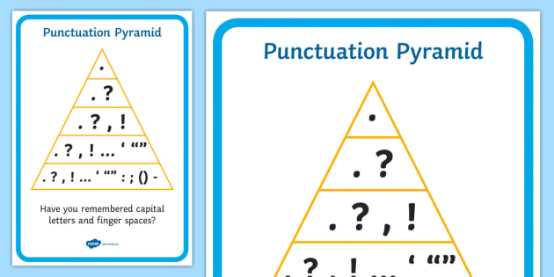 | Verb forms (progressive, simple past)  Singular nouns and plurals  Main and subordinate clauses | Identify different noun types  Consolidate vowel and consonant  Revision of commas in lists  Apostrophe for singular possession | Preposition revision  Apostrophe for regular plural nouns  Dictation including correct punctuation  Sentence subject | Conjunction revision  Sequencing using pictures and written sentences  Collection of verbs ending -ed  Past tense revision | Personal pronoun ‘I’  Pronoun revision  Revision of capital letters for places, people, streets  Revise correct use of adverbs | Vocabulary building – expanded noun phrases and description  Sentence structure  ‘Does it make sense?’
MATHS  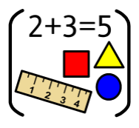 | Multiplication and Division  Multiply by 4  Divide by 4  The 4 times-table  Multiply by 8 | Multiplication and Division  Divide by 8  The 8 times-table  The 2, 4 and 8 times-tables  Multiples of 10 | Multiplication and Division  Related calculations  Reasoning about multiplication  Multiply a 2-digit number by a 1-digit number - no exchange  Multiply a 2-digit number by a 1-digit number - with exchange | Multiplication and Division  Link multiplication and division  Divide a 2-digit number by a 1-digit number - no exchange  Divide a 2-digit number by a 1-digit number - flexible partitioning  Divide a 2-digit number by a 1-digit number - with remainders | Measurement  Scaling  How many ways? Measure in metres and centimetres  Measure in millimetres | Measurement  Measure in centimetres and millimetres  Metres, centimetres and millimetres  Equivalent lengths (metres and centimetres)  Equivalent lengths (centimetres and millimetres)
RE   | Humanism  What is humanism? | Humanism  What is humanism? | Humanism  What makes Humanists happy? | Humanism  Why do humanists think we should be good to each other? | Humanism  How do humanists celebrate in their lives? | Humanism  What do Humanists believe about making a difference?
HISTORY & GEOGRAPHY  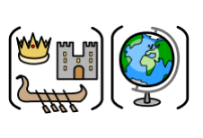 | Ancient Egypt  LI: To compare and contrast Ancient and modern-day religions | Ancient Egypt  To recognise the Egyptian Gods and what they represented | Ancient Egypt  To understand the importance of animals in Ancient Egypt. | Ancient Egypt  To investigate why the Ancient Egyptians built pyramids | Ancient Egypt  To understand what archaeology can tell us about ancient beliefs | Ancient Egypt  To describe the importance of Howard Carter’s Discovery
PE  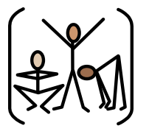 | Outdoor PE  Football  To use the inside of the foot to pass the ball. | Outdoor PE  Football  To trap a ball that is moving along the ground with control. | Outdoor PE  Football  To pass the ball accurately into space over a short distance. | Outdoor PE  Football  To identify and move into space to receive the ball. | Outdoor PE  Football  To use the outside of the foot to control the ball to dribble. | Outdoor PE  Football  To cushion the ball when receiving it. | .
 | Outdoor PE  Cricket  To hit a stationary ball into space using the straight drive. | Outdoor PE  Cricket  To bowl underarm to a batter with some consistency. | Outdoor PE  Cricket  To use the correct footwork to strike a bowled ball. | Outdoor PE  Cricket  To stop a moving ball using the long barrier. | Outdoor PE  Cricket  To throw longer distances overarm. | Outdoor PE  Cricket  To perform as a wicketkeeper.
PSHE   | Dreams and Goals  Assess Prior Knowledge | Dreams and Goals  Identify a dream/ ambition that is important to me | Dreams and Goals  To enjoy facing new learning challenges and working out the best ways for me to achieve them | Dreams and Goals  To be motivated and enthusiastic about achieving our new challenge | Dreams and Goals  To recognise obstacles which might hinder my achievement and take steps to overcome them | Dreams and Goals  To evaluate my own learning process and identify how it can be better next time | Dreams and Goals Assessment Task
MUSIC  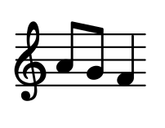 | Recorder  Assess prior knowledge of instruments | Recorder  Identify and play the note B | Recorder  Identify and play the note A | Recorder  Identify and play the note G | Recorder  Play a simple melody | Recorder  Consolidation | Recorder  Consolidation
FRENCH  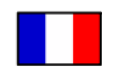 | Make simple statements about what you do well | Express praise | Learn months of the year | Know my birthday and write an invitation | Ask permission to do something | Talk about sports day activities | Assessment Task
SCIENCE   | Forces  Assess prior knowledge | Forces  Understand the effects of friction | Forces  Understand the effects of friction | Forces  Explain the benefits and drawbacks of friction | Forces  Classify magnetic materials | Forces  Assessment task
COMPUTING   | Creating media (Stop-frame animation)  Can a picture move? | Creating media (Stop-frame animation)  Create frame by frame movements | Creating media (Stop-frame animation)  Plan the animation | Creating media (Stop-frame animation)  Create the animation | Creating media (Stop-frame animation)  Evaluate the animation | Creating media (Stop-frame animation) Perfect the animation | Creating media (Stop-frame animation) Consolidation
COMPUTING  including Online-  Safety | Online Reputation  Assess prior knowledge | Online Reputation  Explain how to search for information online | Online Reputation  Explain how to search for information about others online | Online Reputation  Give examples of what anyone may or may not be willing to share about themselves | Online Reputation  Explain the need to be careful before sharing anything personal online | Online Reputation  Explain who someone can ask if they are unsure about putting something online
ART & DESIGN TECHNOLOGY  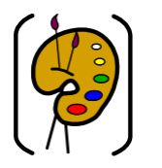 | Art - Working with shape and colour  Explore a piece of artwork | Art - Working with shape and colour  Paint with scissors | Art - Working with shape and colour  Use collage with cut elements | Art - Working with shape and colour  Finalise a collage | Art - Working with shape and colour  Add more detail to a collage | Art - Working with shape and colour  Share, reflect and discuss our artwork.

The full list of books that could be used this term can be found on the website @link, but will include:


