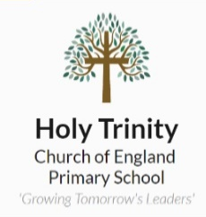
Homework Tasks

Maths – This year, we will be using My Maths for children to complete their homework tasks, log-in details to follow.
Reading – 10-15 minutes of daily reading to be logged in reading record books.
Spellings / Writing Task – Learn spellings and complete a paragraph or write some sentences using the words in context.
In addition to completing the Maths, Reading and Spellings tasks, the grid below hosts a range of homework tasks to complete over the course of the Term.
There are 9 tasks to choose from, and we would like to see that by the end of the term, you have completed at least 3 of them. If you choose to complete more, that is acceptable.
Take a look and choose the ones that you think will help you the most in your learning in school. Homework books should be brought into school each Monday. They will be marked and handed back on Wednesday.
Humanities  When did the Ice Age, Stone Age, Bronze and Iron Ages occur along a timeline?  Research online and design your own creative chronological timeline. | Humanities  Compare how humans survived in the Stone Age, Bronze Age and Iron Age.  Record 3 differences and 3 similarities you found. | Humanities    Where is Britain on a map? On a globe? On Google Earth?  What are some nearby countries, continents or cities?  Note down what you find out.
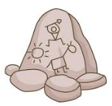  Humanities  Were there any rulers during the Stone, Bronze or Iron Ages?  Record any brief information about those rulers.  Are they similar or different to our current rulers of Britain? | RE  What is Vaisakhi?  Create an information poster on what Vaisakhi is, why it is celebrated, and any other facts you find. | GPS  Get creative! Draw, paint or collage a bank of words that are used as coordinating conjunctions and subordinating conjunctions. Give examples of which ones are used best in a sentence.
Science  What is the life cycle of a plant?  Create various stages of a plant’s life cycle from a range of objects, playdough or images. Write a short sentence to describe these stages. | Maths  Challenge a family member, sibling or friend to a game of ‘Hit the Button’ to continue working on your multiplication.  Hit the Button - Quick fire maths practise for 6-11 year olds (topmarks.co.uk) | 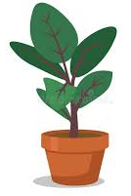  Science  What is needed for flowers to grow?  How does light affect a plant’s growth?  Plant your own seed, or purchase your own plant and find out if it prefers a dark room, or well-lit room in order to grow or bloom!

