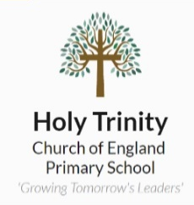
Homework Tasks

Maths – Usernames and passwords have been given out for MyMaths and TTRS.
Please complete the weekly assigned tasks online.

Reading – 10-15 minutes of daily reading to be logged in reading record books. Completing Accelerated Reader quizzes will help support comprehension of the texts, along with questioning.

Spellings / Writing Task – Learn spelling pattern provided in class that week. Work on patterns for check-ins on Fridays. Complete a paragraph or write some sentences using the words in context. Feel free to use your spelling words to play games or create images with the words hidden inside.

In addition to completing the Maths, Reading and Spellings tasks, the grid below hosts a range of homework tasks to complete over the course of the Term.
There are 9 tasks to choose from, and we appreciate any learning you bring in.
Homework books should be brought into school each Monday. They will be marked and handed back on Wednesday.
Humanities  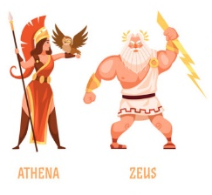  Research one Greek God/Goddess.  Create a poster about them. Be as creative as you’d like! | GPS  Write a diary entry as a Greek child.  Re-read your passage (proofread), showing where you made edits. This will help your self-edit in school. | Science  Grow your own!  Choose a seed from the class selection and grow your own plant.  What worked best for it to grow? Water? Soil? Light? Dark? Take pictures or draw your plant as it grows throughout the term.
Humanities  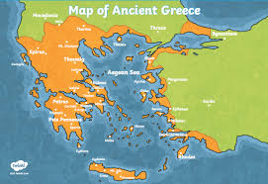  Where is Ancient Greece?  What cities are there? Famous rivers?  Use Google Maps to identify where this location is, noting down any seas, cities, countries around it. | RE  Sikh Religion    Research the 5Ks and complete the questions.  (See page below for information). | Humanities    How did the Olympics begin?  Who were the participants?  What events did they have?  Re-create an Olympic event of your choice with your family!  Who will win?
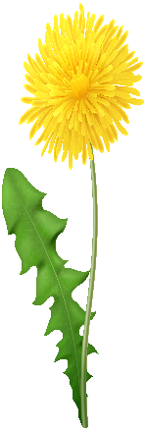  Science  What do you know about plants?  Draw your favourite plant and label its parts. | Maths  Option 1: Create a word problem based on one of our concepts learned so far. Challenge a friend, parent, sibling or family member to solve your problem!  Option 2: Have a go at some activities on MyMaths or TTRS. How did you get on? | DT  Research ancient and modern-day Greek buildings. Can you re-create a building using marshmallows and spaghetti?  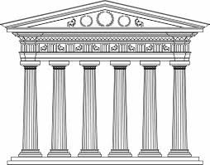  Take a photo of your creation to send it.


Sikhi: The Five Ks

1. Why are the Five Ks called the Five Ks?
_________________________________________________________________________________________________________________________________________________________________________________________________________________________________
2. What must all men and women do to show that they are Sikh?
_________________________________________________________________________________________________________________________________________________________________________________________________________________________________

3. List the Five Ks and why they are symbolic.
a._____________________________________________________ ______________________________________________________
b._____________________________________________________ _______________________________________________________
c._____________________________________________________ _______________________________________________________
d._____________________________________________________ _______________________________________________________
e.______________________________________________________ _______________________________________________________
4. Is there a connection between any of the 5Ks?
________________________________________________________________________________________________________________________________________________________________________________________________________________________________

