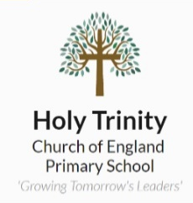
Homework Tasks

Maths – We are using MyMaths for children to complete their homework tasks, log-in details have been given, and will be given out again on parents evening.
Reading – We suggest reading 10-15 minutes daily. This is to be logged in reading record books.
Spellings / Writing Task – Learn the correct spellings for spelling test. You can complete a paragraph using the spelling words or write some sentences using the words in context.

Additionally, to the above, you will find below a grid full of possible homework tasks to complete.
There are 9 to choose from and we would like to see that by the end of the term, you have completed at least 3 of them.
Take a look and try to choose the ones that you think will help you the most.
GPS  Create one poster about one of the different word classes: nouns, verbs, adjectives, adverbs. | Writing  Write a set of instructions for someone in your book on how to do something.  It can be on anything you wish! | Humanities  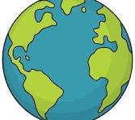  What is a continent?  How many continents are in the world?  Which continent do we live on?
Humanities  Research hieroglyphics from the Ancient Egyptian era.  Create a message in your books using the hieroglyphics for a family member or friend to solve. | RE  What is a promise?  Write down one promise you will make with your family?    Write it down and add images to help illustrate your promise. | GPS  a, an, the, these, those, that?  Design an information poster to help someone understand when to use the correct determiner/article in a sentence. Is there a rule or clever way to remember?
Science  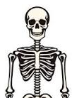  Create a human skeleton image using cotton buds or other materials.  Which bones can you name on your skeleton? | Maths  Complete a TTRS or a MyMaths task.  How did you get on?  Record your score in your book. | Science  What are the main food groups that we need to eat to keep healthy?  Draw an image of a good plate of food. Label your foods.

Homework books should be brought into school by Wednesday.

