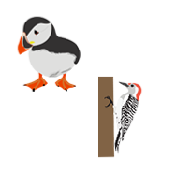
Year 3 Termly Plan 1

SUBJECT | WEEK 1 | WEEK 2 | WEEK 3 | WEEK 4 | WEEK 5 | WEEK 6 | WEEK 7 | WEEK 8
GUIDED READING   | The Wild Robot  Explore a new text.  Vocabulary.  Retrieval. | The Wild Robot  Summary and Sequence.  Retrieval.  Inference.  Dig deeper into a text, specific to the characters and their qualities. | The Wild Robot  Vocabulary  Retrieval. Inference.  Dig deeper into characters - How do perceptions change? | The Wild Robot  Vocabulary.  Retrieval.  Summarise and sequence.  Inference. | The Wild Robot  Retrieval.  Summarise and sequence.  Inference.  Dig Deeper – characters change throughout story. | The Tree and the River  Explore a new text.  Explain the meaning of pictures in context.  Retrieve information.  Summarise and sequence. | The Tree and the River  Retrieval based on pictures.  Make justified inferences based on the images in the text.  Connections and meanings.  Prediction. | Comprehension Tasks for Consolidation
WRITING   | Character Description  Immersion lesson.  Features of a character description.  To gather vocabulary and conjunctions.  To use emotive language. | Character Description  Plan a character description.  Write a character description.  Edit and improve. | Instructional Text  Immersion and features (egg).  Vocabulary and phrases.  To write about how to look after a gosling. | Instructional Text  Immersion.  Identify features of an instructional text.  Vocabulary and phrases.  Identify and gather appropriate time conjunction. | Instructional Text  Plan an instructional text.  To write about how to look after a gosling.  Edit and publish. | Non-Chronological Report  What’s the best animal? debate.  Features of NCR.  Gather research based on a chosen animal. | Non-Chronological Report  Planning the introduction.  Planning the subheadings and information.  Planning the conclusion. | Non-Chronological Report  Write NCR.  Edit and Improve.
MATHS  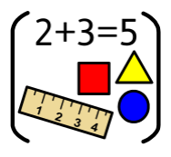 | Number and Place Value  Read and write numbers to 100.  Represent numbers to 100.  Partition numbers to 100. | Number and Place Value  Read and write numbers to 1000.  Represent numbers to 1000.  Partition numbers to 1000. | Number and Place Value  Find 1, 10 and 100 more or less than a number.  Compare and order numbers up to 1000.  Estimate numbers on a number line. | Four Operations  Recall number bonds to 100.  Add three-digit numbers using mental strategies.  Add three-digit numbers using written strategies.  Add three-digit numbers using written strategies (with exchange). | Four Operations  Use inverse with number bonds.  Subtract three-digit numbers using mental strategies.  Subtract three-digit numbers using written strategies.  Subtract three-digit numbers using written strategies (with exchange). | Four Operations  Solve missing number problems.  Solve single-step problems.  Solve multi-step problems.  Reason with addition and subtraction. | Four Operations  Recall 2s, 5s and 10s.  Know three times tables.  Know four times tables.  Know eight times tables.  Count from 0 in multiples of 4, 8, 50 and 100. | Four Operations  Calculate multiplication statements mentally.  Use linking facts to solve mental multiplication calculations involving 2-digit by 1-digit.  Calculate 2-digit by 1-digit multiplication using a written method.
RE   |  | People of God  What is the Bible made up from? | People of God  What kind of person was Noah? | People of God  What was  God’s covenant with Noah? | People of God  What is a covenant? | People of God  When are covenants made? | People of God  Why are promises made / needed? | People of God  Consolidation of learning
HISTORY &  GEOGRAPHY  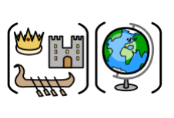 | History – Early Civilisations  To assess prior knowledge | History – Early Civilisations  To understand the concept of a civilisation | History – Early Civilisations  To explore the inventions of Ancient Sumner | History – Early Civilisations  To investigate the achievements of the Indus Valley Civilisation | History – Early Civilisations  To explore the Shang Dynasty | History – Early Civilisations  To learn about society and culture of Ancient Egypt | History – Early Civilisations  To compare and contrast the earliest civilisations | History – Early Civilisations  Assessment Task
PE  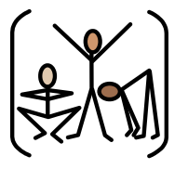 | Indoor – Gymnastics  To show full extension during a balance. | Indoor – Gymnastics  To move in and out of contrasting shapes with fluency. | Indoor – Gymnastics  To perform a sequence using different types of rolls. | Indoor – Gymnastics  To perform powerful jumps from a low apparatus. | Indoor – Gymnastics  To perform in unison with partner to mount apparatus. | Indoor – Gymnastics  To create a group performance using contrasting actions. | Indoor – Gymnastics  To refine the group perform using contrasting actions. | Indoor – Gymnastics  To perform in front of others.
 | Outdoor – Football  To use the inside of the foot to pass the ball. | Outdoor – Football  To trap a ball that is moving along the ground with control. | Outdoor – Football  To pass the ball accurately into space over short distances. | Outdoor – Football  To identify and move into space to receive the ball. | Outdoor – Football  To use the outside of the foot to control the ball and dribble. | Outdoor – Football  To cushion the ball when receiving. | Outdoor – Football  To play small-sided games with teammates. | Outdoor – Football  To compete in tournament style games.
PSHE   | Creating a class charter and class set of rules | Being Me in My World Recognising my worth and setting goals | Being Me in My World  Facing new challenges positively | Being Me in My World  Understanding why rules are needed and how they relate to rights and responsibilities | Being Me in My World Understanding that my actions affect myself and others | Being Me in My World  Make responsible choices and take action | Being Me in My World  Understand actions and use empathy | Being Me in My World  Consolidate learning
MUSIC  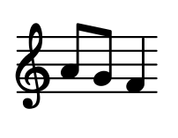 | Musicianship  Appraise and compare a range of music from different genres. | Musicianship  Appraise music from different countries. | Musicianship  Know meaning of the word pulse/beat and how to find it in music. | Musicianship  Know the meaning of the word rhythm and be able to apply this knowledge effectively to create simple patterns. | Musicianship  Know the meaning of the word pitch and how to apply this knowledge to listening to, singing and playing notes. | Musicianship  Recall knowledge of pulse, pitch and rhythm. | Musicianship  Apply knowledge of pulse, pitch and rhythm. | Musicianship  Apply knowledge of pulse, pitch and rhythm.
FRENCH  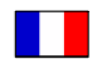 | Introduction  Greetings and introductions such as ‘Hello’ and ‘How are you?’ | Introduction  Questions such as ‘What is your name?’ and ‘How old are you?’ | Introduction  Learning names for family roles | Introduction  Learning names for family roles | Introduction  Numbers 1-20 | Introduction  Singular and plural of common nouns | Introduction  Responding to instructions | Introduction  Consolidating all skills through conversations
SCIENCE   | Animals and Humans  Identify that animals, including humans, need the right types and amount of nutrition in their diet. | Animals and Humans  Classify animals into vertebrates and invertebrates. | Animals and Humans  Compare animal and human skeletons. | Animals and Humans  Know what bones are made from. | Animals and Humans  Identify that humans and some other animals have muscles for support, movement and protection. | Animals and Humans  Explain how exercise and healthy eating impact positively on humans. | Animals and Humans  Create a leaflet on healthy eating and exercise. | Animals and Humans  Create a leaflet on healthy eating and exercise.
COMPUTING   | Connecting Computers  To assess prior knowledge. | Connecting Computers  To identify the parts that make up a digital device. | Connecting Computers  To look at how digital devices help us. | Connecting Computers  To find out how I am connected to other digital devices. | Connecting Computers  To identify how computers are connected. | Connecting Computers  To identify what our school network looks like. | Connecting Computers  Consolidation | Connecting Computers  Consolidation
ART & DESIGN TECHNOLOGY  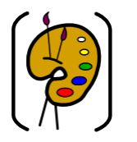 | Drawing with Charcoal  Explore the use of charcoal in Art | Drawing with Charcoal  Explore charcoal | Drawing with Charcoal  Explore charcoal | Drawing with Charcoal  Personalise the journey | Drawing with Charcoal  Find Your Focus – Charcoal & Drama or Charcoal & Dance | Drawing with Charcoal  Find Your Focus – Charcoal & Drama or Charcoal & Dance | Drawing with Charcoal  Present & Review | Drawing with Charcoal  Gallery Showcase in Classes
SPIRITUAL  DEVELOPMENT  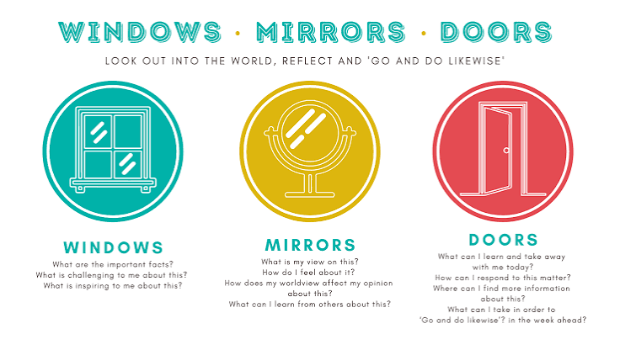  (Windows, Mirrors and Doors) | Window: Children experience awe and wonder at the beauty and diversity of God's creation through the description in Wild Robot.  Mirror: What am I thankful for? How would I feel if I was lost?  Door: Choose one way to show kindness and care for nature. | Window: Early civilisations have opened up real-life situations of people long ago.  Mirror: How do I express my feelings when things are changing?  Door: Write with empathy, honesty and hope for the future. | Window: Children notice that despite being different outside, animals and humans both have similarities inside.  Mirror: What do I sometimes take for granted? Who helps me to have what I need?  Door: Identify one way to care for myself, others or animals. | Window: Harvest helps children appreciate food as a gift and notice the people who provide it.  Mirror: Who and what am I grateful for?  Door: Respond through thankfulness, generosity and sharing with those in need. | Window: Children encounter beauty, colour and creativity through understanding how their words and actions affect others.  Mirror: How can what I do or say affect others?  Door: Create opportunities to share kindness towards one another. | Window: Moving together as a unit through performing arts can create a sense of unity.  Mirror: How does moving together in unison with others make observers feel?  Door: Encourage others and celebrate their contributions respectfully. | Window: Children notice that promises made will impact others in profound manners.  Mirror: What responsibility do I have to care for God's world? Door: Make a personal pledge to look after creation through one achievable action. | SPIRITUAL  DEVELOPMENT  (Windows, Mirrors and Doors)
The full list of books that could be used this term can be found on the website @link but will include:



