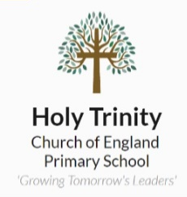
Homework Tasks

Maths – This year, we will be using My Maths for children to complete their homework tasks, log-in details to follow.
Reading – 10-15 minutes of daily reading to be logged in reading record books. These are to be brought into school daily for checking.
Spellings- Learn spellings attached below ahead of spelling test each Monday.
Additionally, to the above, you will find below some possible homework tasks to complete.
There are 9 to choose from and we would like to see that by the end of the term, you have completed at least 3 of them in your homework books.
Take a look and try to choose the ones that you think will help you the most.

History  Research about Roman culture in the UK. This can include their food, clothing, housing, music and art. You may present your work however you like, and you will be able to use your research in our writing lessons. | Science  Find out some facts about our teeth. For instance, the different types of human teeth, the functions of different types of teeth and the problems that could arise if we do not brush our teeth regularly. | History  Research about Boudicca. Who was she? Why was she important? Did she succeed in what she set out to do? Challenge: look at images of Celtic and Roman battle armour and consider whether this had an impact on the outcome of the Roman invasion.
Science  What is a food chain and why are they used?  Can you create some food chains? | RE  What do Christians believe about how the world was created?  Present your findings as a poster or a piece of writing. | EGPS  What are nouns, verbs, adverbs and adjectives?  Show your understanding however you wish.
Geography  Recall your knowledge from previous years- what is a country? What is a continent?  List some in your books. | History  What is an emperor? How many Roman emperors were there? Research about one chosen Roman emperor. | EGPS  What are fronted adverbials?  Can you write some sentences which use fronted adverbials and underline the fronted adverbial within it?

Homework books should be brought into school each Monday and will be sent home again on Wednesday.

